

NAME OF SCHEME

NAME OF STRUCTURE Environmental Barrier (3.0) Timber Reflective as pictured below

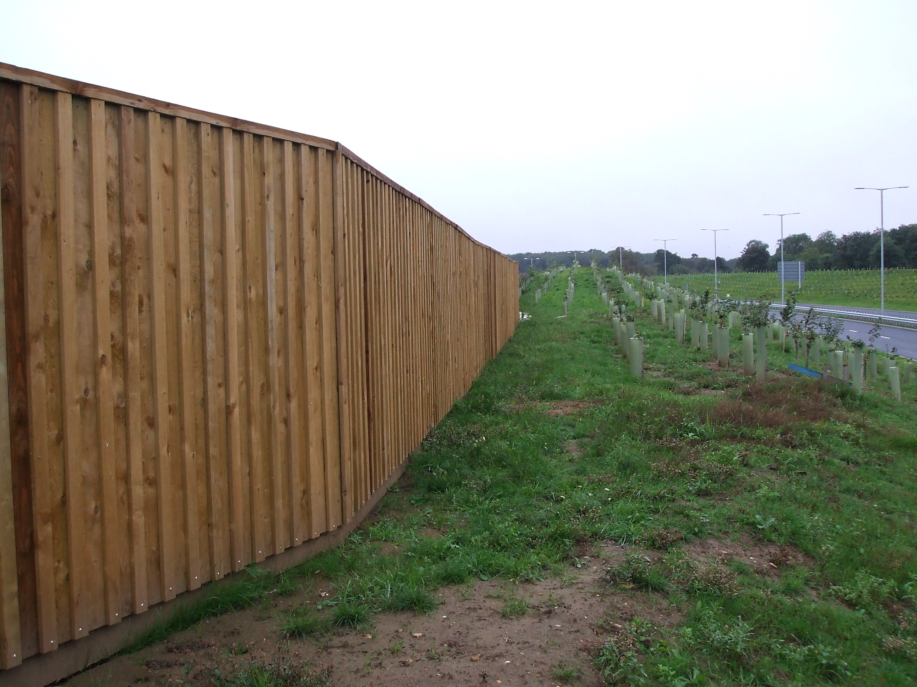

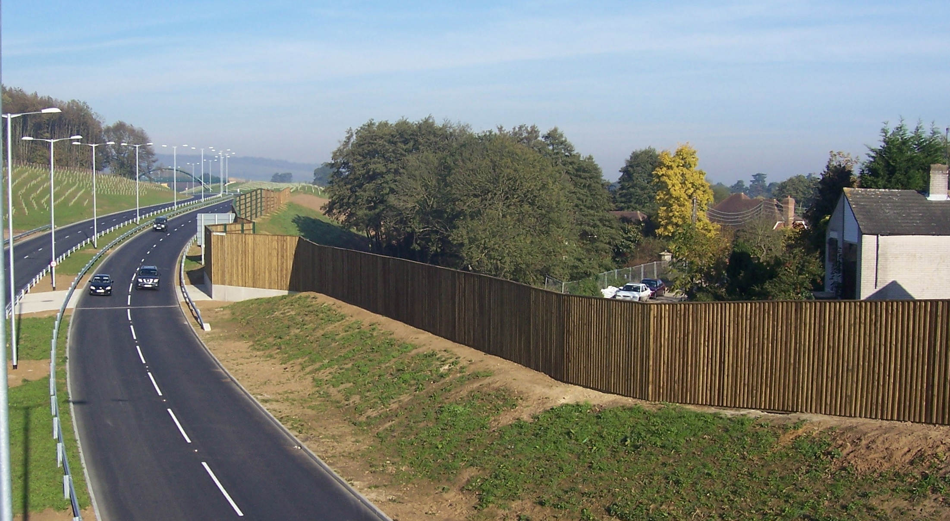

Description of Structure

The fences are 2.0 metre high acoustic barriers in accordance with Clause 2504 of the specification for Highway Works. (1998 consolidation version) and Departmental Standard HA 66-95 – Environmental Barriers: Technical Requirements.

The fence has been laboratory tested in accordance with BS EN 1793:1998 (Parts 1-3) and has reached performance category B3 or A3.

The installation will be carried out by an installer registered to BS 9001:2000 Sector Scheme Document 2 C (The Design, Supply, Installation and Repair of Environmental Barriers (Structural))

Structural Type

The supporting posts are vertical cantilevers in structural steel sections embedded into mass concrete foundations of 1m depth x 0.45m diameter.

The infill panels are constructed using timber rails spanning horizontally between the supporting posts and vertical timber boards spanning continuously over the rails.

Absorptive panels will have a rockwool infill with a protective membrane over the face.

Foundation Type

The barrier will be founded in the existing ground on mass concrete foundations.

Span Arrangements

Height of fence 2.0m

Span of panels 3.0m

Articulation Arrangements

The posts act as vertical cantilevers and the panels act as simply supported one-way spanning slabs.

Proposed Arrangements for Inspection and Maintenance

Design life – 40 years, no major maintenance for 20 years. The environmental barrier should be inspected for maintenance during normal routine highway boundary inspections.

Materials and Finishes

Environmental Barrier:

The posts will be UB section steel Grade S275JR to BS EN 10025:1993, and will be galvanised to BS EN ISO 1461:1999, after fabrication. The posts will be embedded into isolated mass concrete foundations to a depth of 1m x 0.45 m diameter. The concrete mix for the foundations will be ST5 and there are no special requirements for resistance to ground sulphates for this site.

The timber components of the barrier will be treated using Tanalithe “E” (Green). The top will be finished with a once weathered capping. The reflective face of the fence will consist of 150mm*22mm vertical boards and 65mm cover strips, nailed through into the rails and gravel board using galvanised annular ring shank nails.

All timber to be preservative treated to BS 5589:1989.



